SECTION A - 11 marks (Attempt all questions from this Section.)
- Choose the correct answers to the questions from the given options. (Do not copy the questions, write the correct answers only.)
- Element ‘P’ has electronic configuration 2,8,8,1. The number of chlorine atoms present in the chloride of P is:
- 2
- 1
- 3
- 4
- ₁H² is an isotope of hydrogen. In the modern Periodic table it will:
- Be placed before hydrogen
- Be placed after hydrogen
- Be placed at the same position as hydrogen
- Not have any position in the Periodic table
- Which of the following electronic configuration represents the most electropositive element?
- 2,1 (b) 2,8,1 (c) 2,2 (d) 2,8,2

- Assertion (A): Alkali metals do not form dipositive ions.
Reason(R): After the loss of one electron, alkali metals achieve stable electronic configuration of noble gases.
- Both A and R are true and R is the correct explanation of A.
- Both A and R are true and R is the correct explanation of A.
- A is true but R is false.
- A is false but R is true.

- Assertion (A): The tendency of losing electrons increases down the group. Reason (R): The most reactive metal is placed at the top of Group 1.
- Both A and R are true and R is the correct explanation of A.
- Both A and R are true and R is the correct explanation of A.
- A is true but R is false.
- A is false but R is true
- Given there are four ions: Cl–, Li⁺, Al³⁺ , K⁺ Identify the pair of ions which have the same electronic configuration.
(a) Cl– & Li⁺ (b) Al³⁺ & K⁺ (c) Cl– & K⁺ (d) Li⁺ & K⁺

- X, Y & Z are three metallic atoms in successive order belonging to the same group such that atomic radii of ‘X’ is the smallest. Which of the three atoms is the best reducing agent?
(a) X (b) Y (c) Z (d) All three have the same reducing power
- In the 2nd period Neon has maximum Ionization Potential because:
- It has unstable electronic configuration.
- It easily accepts electrons.
- It easily loses electrons.
- The outer most shell is completely filled
- Electron Affinity is maximum in:
- Mg
- Ar
- Li
- Br
- (i) State the terms: (a) The tendency of an atom to attract the shared pair of electrons towards itself when combined in a compound.
(ii) Complete: (a) If an element has one electron in the outermost shell, then it is likely to have the _______atomic size amongst all the elements in the same period.
SECTION B-30 marks [Attempt all questions]
- The atomic number of two atoms ‘X’ and ‘Y’ are 14 and 8 respectively. [2]
State: (a) the period to which ‘X’ belongs.
(b) the formula of the compound formed between ‘X’ and ‘Y’. (do not identify X and Y)
- Study the table given below. Use only the letters given in the table to answer the questions. Do not identify the elements. [3]
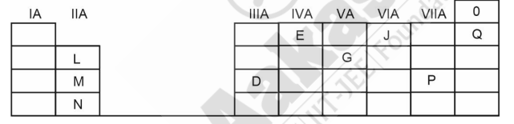
(a) State the valency of element ‘G’.
(b) Which element can exhibit catenation?
(c) Write the formula of the compound formed between ‘M’ and ‘P’.
- Given below are two sets of elements from two different periods. Name the element with the highest ionisation potential in each of the following sets. (a) Al, Cl, Mg (b) Ne, O, F [2]
- The electron affinity of an element X is greater than that of element Y. [3]
(a) How is the oxidising power of X likely to compare with that of Y?
(b) How is the electronegativity of X likely to compare that of Y?
State whether X is likely to be placed to the left or to the right of Y in the periodic table?

- Element ‘X’ forms an oxide with formula X₂O₃ which is a solid with high melting point. ‘X’ would likely to be placed in the group of the periodic table as:
(a) Na (b) Mg (c) Al (d) Si
Justify your answer. [3]
- [3]
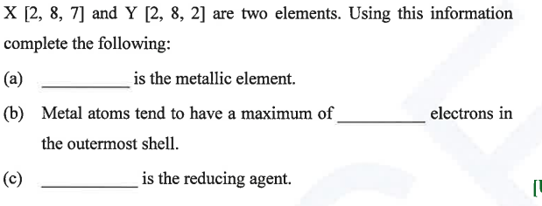
- Name: [3]
(a) An alkali metal in period 3 and halogen in period 2.
(b) The noble gas with 3 shells.
(c) The non-metals present in period 2 and metals in period 3.
(d) The element of period 3 with valency 4.
(e) The element in period 3 which does not form oxide.
(f) The element of lower nuclear charge out of Be and Mg.
- (i) How does size varies: (a) down the group (b) along a period.
Give reason also. [2]
(ii) Why is the size of (i) neon greater than fluorine? (ii) sodium is greater than magnesium? [2]
(iii) Which has higher E.A., Fluorine or Neon. Why? [2]
(iv) Arrange: [2]
(i) Be, Li, C, B, N, O, F (in increasing metallic character).
(ii) Si, Na, Al, Mg, Cl, P, S (in decreasing non-metallic character).
- An element X belongs to 3rd period and 17th group, state [3]
(i) No. of valence electrons in it.
(ii) Name of the element.
(iii) Name the family to which it belongs.
(iv)Write the formula of the compound formed when X reacts with Y.

